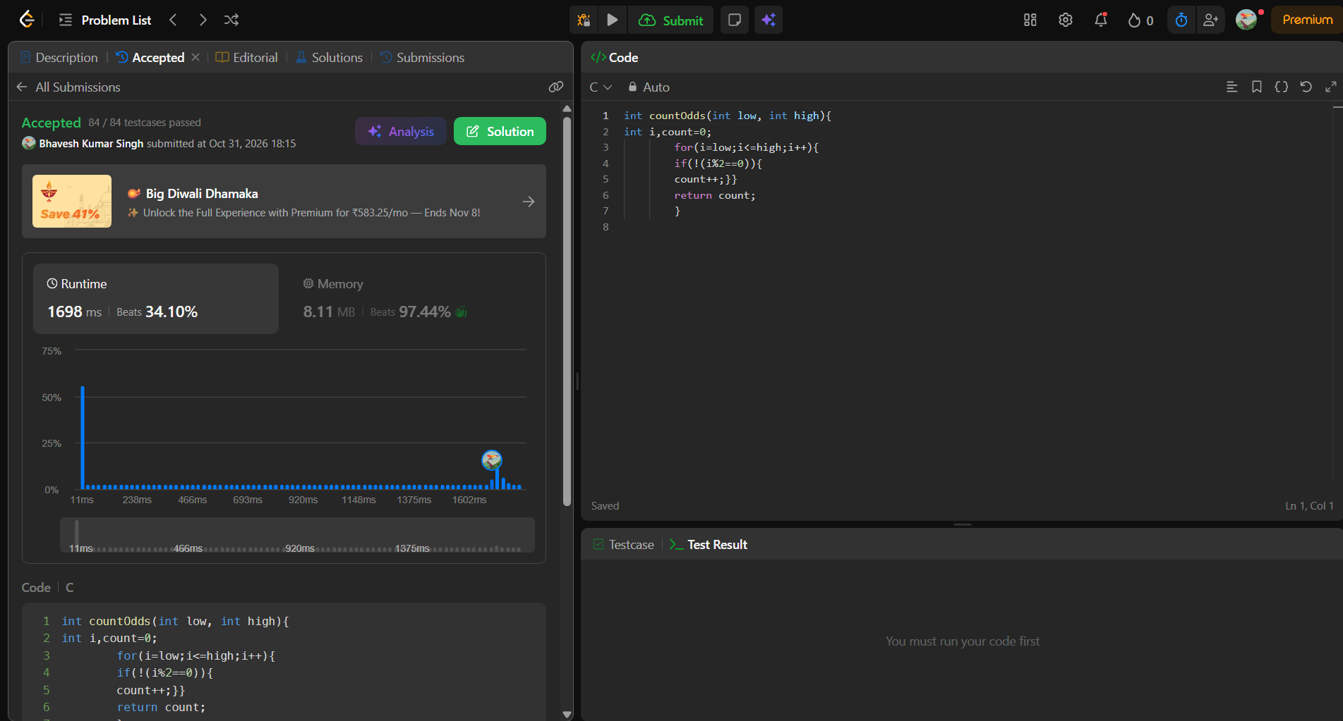
int countOdds(int low, int high){
int i,count=0;
for(i=low;i<=high;i++){
if(!(i%2==0)){
count++;}}
return count;
}

